[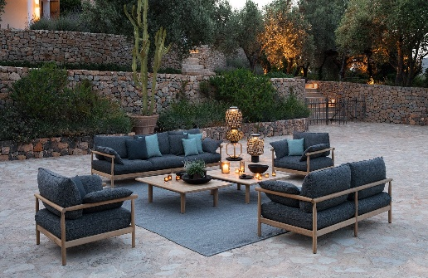](https://www.google.nl/url?sa=i&rct=j&q=&esrc=s&source=images&cd=&cad=rja&uact=8&ved=2ahUKEwjT6uO5nfzeAhWF-6QKHYYiBp4QjRx6BAgBEAU&url=https%3A%2F%2Fsecondluxury.nl%2F&psig=AOvVaw2jpNU_jTciivTR516lA1Fy&ust=1543671168078043)Collage:

[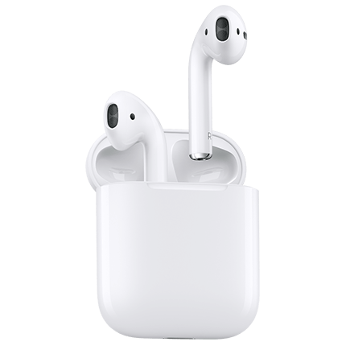](https://www.google.nl/url?sa=i&rct=j&q=&esrc=s&source=images&cd=&cad=rja&uact=8&ved=2ahUKEwjNp5XtnfzeAhWB66QKHUP8Dl8QjRx6BAgBEAU&url=https://www.o2.co.uk/shop/apple/airpods&psig=AOvVaw3ND_j83ZP9l21Vc6Hlv_pa&ust=1543671297950486)

[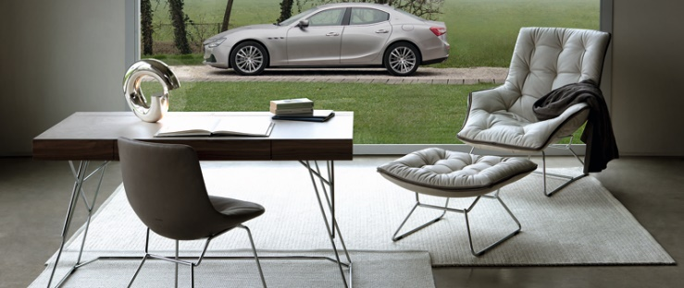](https://www.autoliefhebber.com/autonieuws-luxe-producten-maserati-op-salone-del-mobile-milaan-2014-p-3257.html)[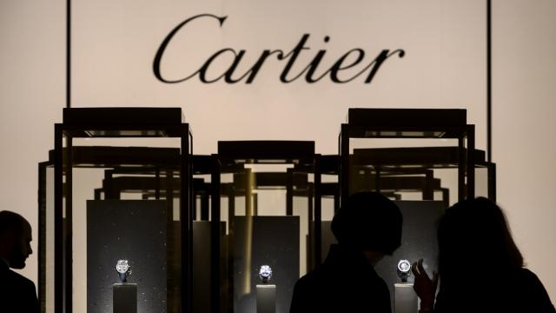](https://www.google.nl/url?sa=i&rct=j&q=&esrc=s&source=images&cd=&cad=rja&uact=8&ved=2ahUKEwiap-rJnvzeAhWmNOwKHd_1Cd0QjRx6BAgBEAU&url=https://www.nu.nl/economie/5271704/maker-luxeproducten-richemont-ziet-vraag-in-azie-stijgen.html&psig=AOvVaw3nDitC6KCZnGWGMkZGkGOf&ust=1543671387188986)[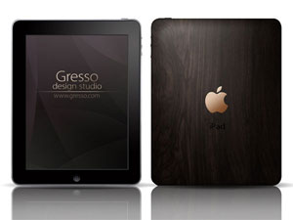](http://www.google.nl/url?sa=i&rct=j&q=&esrc=s&source=images&cd=&cad=rja&uact=8&ved=2ahUKEwju_KK9nvzeAhUH_qQKHTtiCpwQjRx6BAgBEAU&url=http://www.ipadinfo.nl/6355/hout-en-goud-in-je-ipad-by-gresso/&psig=AOvVaw3nDitC6KCZnGWGMkZGkGOf&ust=1543671387188986)[](https://www.google.nl/url?sa=i&rct=j&q=&esrc=s&source=images&cd=&cad=rja&uact=8&ved=2ahUKEwiitsiinvzeAhUSDOwKHdlKAtoQjRx6BAgBEAU&url=https://fr.123rf.com/photo_32133272_deux-membres-vip-privil%C3%A8ge-produits-de-luxe-banni%C3%A8res-publicitaires-noires-horizontales-fix%C3%A9es-avec-des-co.html&psig=AOvVaw3nDitC6KCZnGWGMkZGkGOf&ust=1543671387188986)[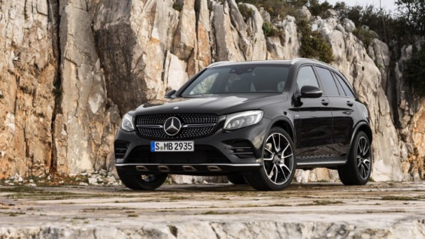](http://www.google.nl/url?sa=i&rct=j&q=&esrc=s&source=images&cd=&cad=rja&uact=8&ved=2ahUKEwiXqYWKnvzeAhUDsqQKHRm9CUUQjRx6BAgBEAU&url=http://autovandaag.nl/autonieuws/12540/zescilinder-voor-mercedes-benz-glc-in-amg-verpakking/&psig=AOvVaw0D3MD9RxvekYpOtbOCiBq-&ust=1543671358228117)[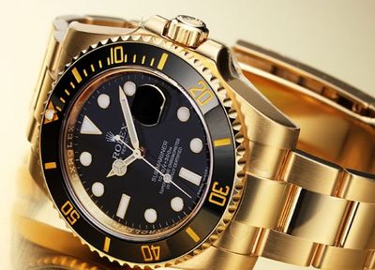](http://www.google.nl/url?sa=i&rct=j&q=&esrc=s&source=images&cd=&cad=rja&uact=8&ved=2ahUKEwizkOKXnvzeAhVOyqQKHaTnDnYQjRx6BAgBEAU&url=http://nr.shop2yacht.com/supply/luxe-artikelen/6/&psig=AOvVaw3nDitC6KCZnGWGMkZGkGOf&ust=1543671387188986)[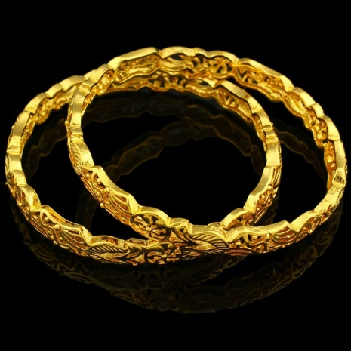](https://www.google.nl/url?sa=i&rct=j&q=&esrc=s&source=images&cd=&cad=rja&uact=8&ved=2ahUKEwj_06DbnfzeAhUK36QKHcmxDFoQjRx6BAgBEAU&url=https://nl.aliexpress.com/item/Luxury-18K-Gold-Plated-Bangle-JewelryTrendy-Dubai-Gold-Bangle-Women-Men-Jewelry-Ethiopian-African-Dubai-Items/32757119477.html&psig=AOvVaw2jpNU_jTciivTR516lA1Fy&ust=1543671168078043)